ECE 311: Digital Signal Processing Lab
Lab 2 Spectral Analysis Report
Xuanying Li
February 16, 2016

Report Item 1:

a. N = 8000 bytes / 8 bytes = 1000 samples.

b. To satisfy Shannon-Nyquist, the maximum frequency fmax < ½fs = 500 HZ, where fs = 1000, therefore the maximum frequency is 500 Hz. To satisfy Rayleigh limit, the minimum frequency fmin > 1/(N∆t) = fs / N = 1Hz, where N = 1000, therefore the minimum frequency is 1 Hz. To satisfy any frequency to captured without aliasing, the frequency needs to be fs/N < f < 1/2fs. The reason for capture both high and low frequency components of a signal in a single acquisition memory intensive is that they need to have a really large N to decreasing fmin and increasing fmax. \

Report Item 2:

a. The spectral copies in Xd(w) comes from DTFT. Since these copies extend to infinity, these additional copies do not have physical significance. Xd(w) will have physical significance when omega in in the range of [-pi, pi].

Report Item 3:

a. An FFT rapidly computes transformations by factorizing the DFT matrix into a product of sparse factor, it manage to reduce the complexity of computing the DFT form. The DFT is a N*N matrix, where the input is an N*1 matrix. The complexity of computing is multiplication and addition, where the total multiplication addition is N*N(MA/row * #s of rows), which is O(N^2).

Report Item 4:
a.
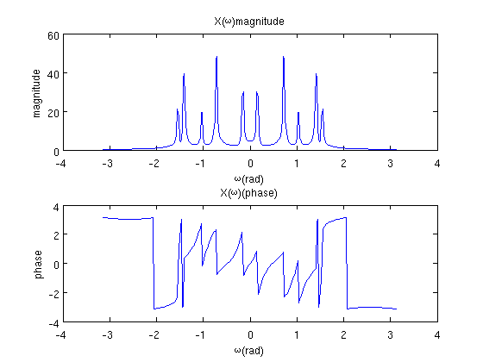

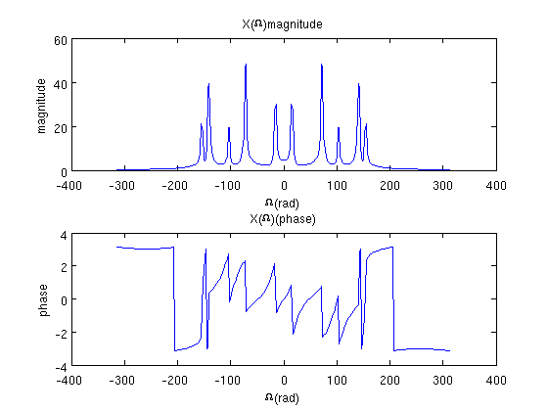
There are 5 frequency tones because of 5 peaks on the positive x-axis of DFT (or from negative x-axis OF DFT.). Read from the graph, their values are 2.33 Hz, 11.33 Hz, 16.67 Hz, 22.33 Hz, and 24.67 Hz.

Report Item 5:

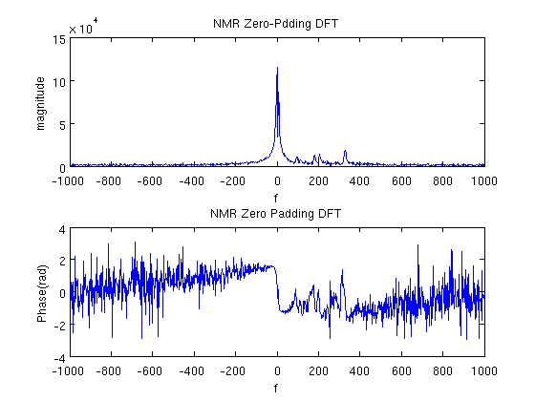

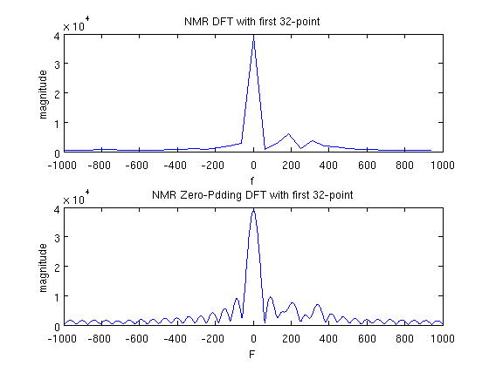
Yes, I can distinguish the peaks corresponding to creatine (around 209 Hz) and chlorine (185 Hz) in zero-padded graph with first 32-point data. Because the less the data used in the graph, the bigger the lobe is. And with the zero-padding, the peaks will be more separated.

Report Item 6.1:
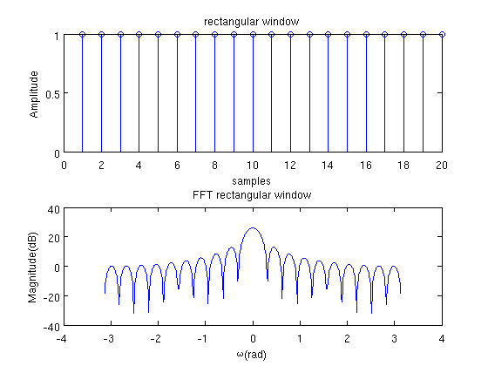

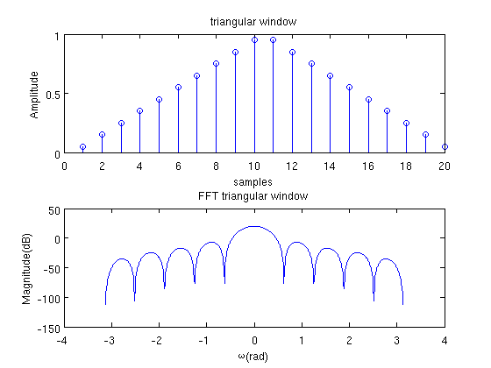

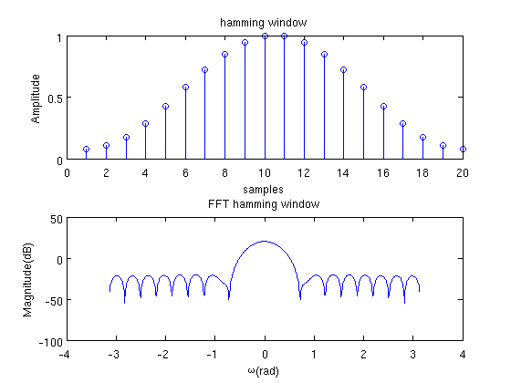
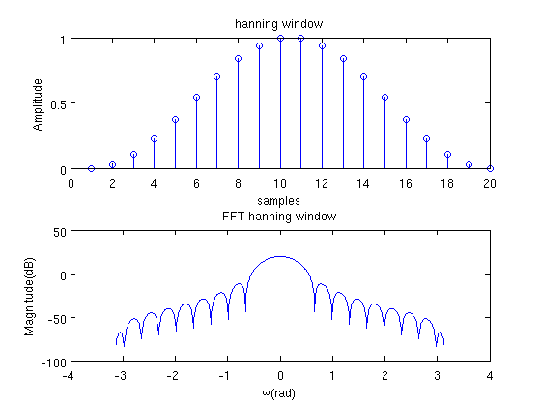
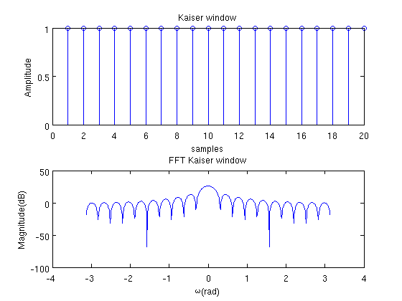
From the graphs we can see that rectangular window has smaller mainlobe width but higher sidelopes compare to triangular window. And rectangular window has higher sidelobes compare to hamming window.

Report Item 6.2:
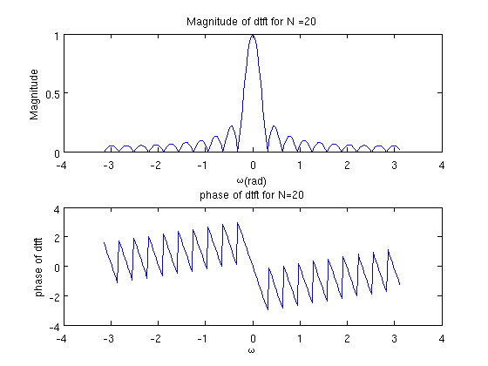
The mainlobe width is 0.62 for N =20.
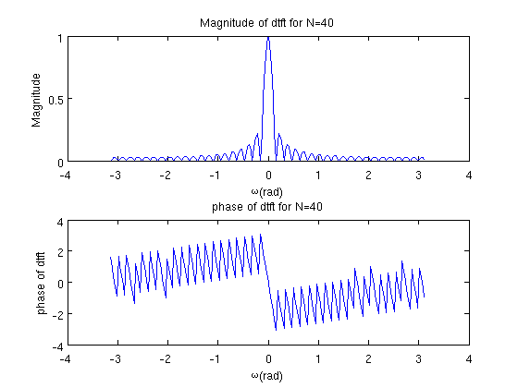
The mainlobe width is 0.31 for N =40

Report Item 6.3
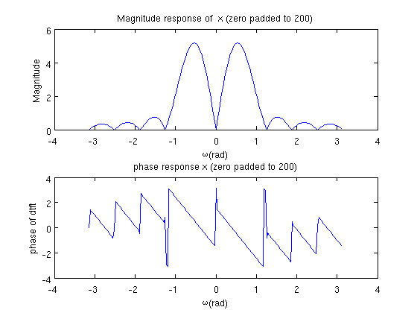

N = 1/(f0*∆t) = 10, where f0 = 5, ∆t = 0.02.

